**Documentation on Monte Carlo Simulation using Markowitz Chain**

**Basic -**

**1-What is Monte Carlo Simulation?**

Monte Carlo simulation, or probability simulation, is a technique used to understand the impact of risk and uncertainty in financial, project management, cost, and other forecasting models.

**Uncertainty in Forecasting Models**

When you develop a forecasting model – any model that plans ahead for the future – you make certain assumptions. These might be assumptions about the investment return on a portfolio, the cost of a construction project, or how long it will take to complete a certain task. Because these are projections into the future, the best you can do is estimate the expected value..

**Estimating Ranges of Values**

In some cases, it's possible to estimate a range of values. In a construction project, you might estimate the time it will take to complete a particular job; based on some expert knowledge, you can also estimate the absolute maximum time it might take, in the worst possible case, and the absolute minimum time, in the best possible case. The same could be done for project costs. In a financial market, you might know the distribution of possible values through the mean and standard deviation of returns. By using a range of possible values, instead of a single guess, you can create a more realistic picture of what might happen in the future. When a model is based on ranges of estimates, the output of the model will also be a range.

**How It Works**

In a Monte Carlo simulation, a random value is selected for each of the tasks, based on the range of estimates. The model is calculated based on this random value. The result of the model is recorded, and the process is repeated. A typical Monte Carlo simulation calculates the model hundreds or thousands of times, each time using different randomly-selected values. When the simulation is complete, we have a large number of results from the model, each based on random input values. These results are used to describe the likelihood, or probability, of reaching various results in the model.

2- **Markowitz Chain**

Markowitz formulated the variance (or risk) theory of a generic portfolio composed of *n* assets and showed that it depends on the variances of individual assets and the covariance’s between pairs of assets involved, as originally published in the following formula:

http://www.ijmp.jor.br/index.php/ijmp/article/viewFile/156/387/3590

Where:

*X*  =     asset participation in the portfolio

*σij*=     covariance between asset *i*and asset *j*

*n*   =    number of assets

            Sharpe (1964) developed the fundamentals of asset pricing by taking into account the conclusions of Markowitz portfolio risk. Among its conclusions, he emphasizes that there is a linear relationship between the rates of return on assets and their covariance with the market portfolio. This relationship is expressed by beta (*β*), a standardized covariance to the market portfolio variance. Therefore, there is a linear relationship between the return on assets and *β* defined by:

http://www.ijmp.jor.br/index.php/ijmp/article/viewFile/156/387/3592

Where:

http://www.ijmp.jor.br/index.php/ijmp/article/viewFile/156/387/3594asset expected return

*RF* =  risk-free rate

http://www.ijmp.jor.br/index.php/ijmp/article/viewFile/156/387/3596  beta of the asset

*RM* = market expected return

**3-Excel Sheet**

**(i)- Stock-**

We have take five Stock-

(a)- AKITA DRILLING LIMITED

(b)- ALGOMA CENTRAL CORPORATION

(c)- ANDREW PELLER LIMITED

(d)- ATCO LIMITED

(e)- BCE INCORPORATED

These are the given Stock. We have take the data of from **1/Jan/1999** to **1/Jan/2015.**

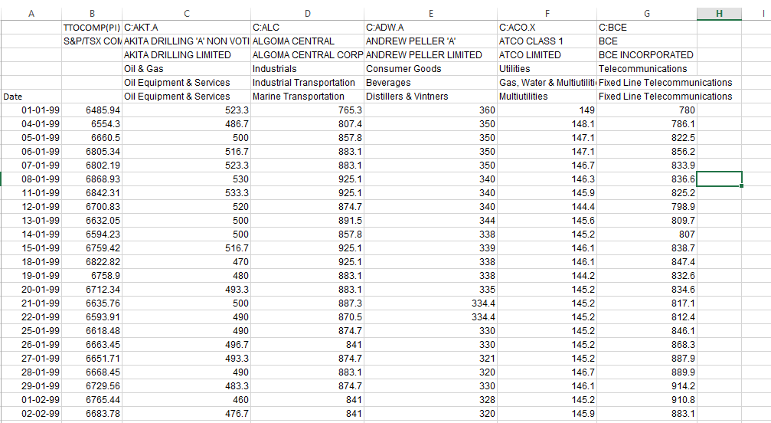

**(ii)-Correlation Martix**

A correlation matrix is a table showing [correlation coefficients](https://www.statisticshowto.datasciencecentral.com/probability-and-statistics/correlation-coefficient-formula/) between sets of variables. Each [random variable](https://www.statisticshowto.datasciencecentral.com/random-variable/) (Xi) in the table is correlated with each of the other values in the table (Xj). This allows you to see which pairs have the highest correlation.

[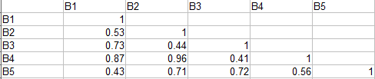](https://www.statisticshowto.datasciencecentral.com/wp-content/uploads/2016/05/correlation-matrix.png)

*A correlation matrix showing correlation coefficients for combinations of 5 variables B1:B5.*  
The diagonal of the table is always a set of ones, because the correlation between a variable and itself is always 1. You could fill in the upper-right triangle, but these would be a repeat of the lower-left triangle (because B1:B2 is the same as B2:B1); In other words, a correlation matrix is also a [symmetric matrix](https://www.statisticshowto.datasciencecentral.com/matrices-and-matrix-algebra/#SymmetricM).

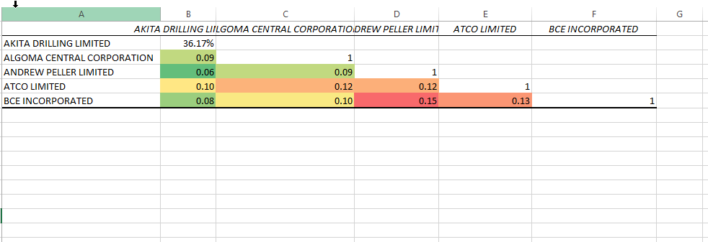 Correlation Matrix of Given five Stock

**(iii)-Return of each Stock Date wise**

Total **return** is expressed as a percentage of the amount invested. For example, a total **return** of 20% **means** the security increased by 20% of its original value due to a price increase, distribution of dividends (if a **stock**), coupons (if a bond) or capital gains (if a fund).

**Formula=** log (Stock price on nth day/Stock price on n+1 day)

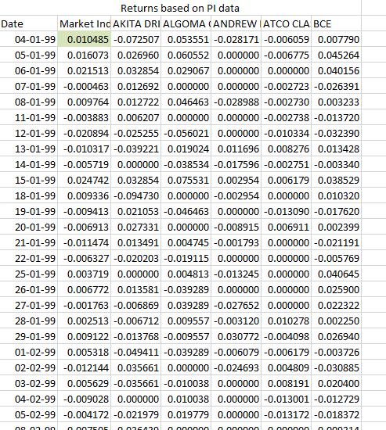

Return of each stock per day

**(iv)-Return Graph**

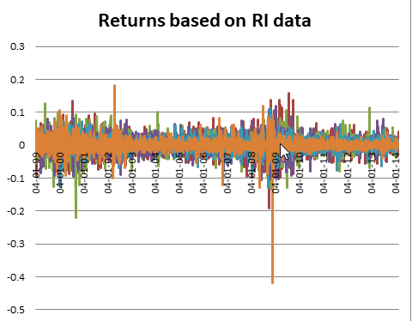

Return Based on RI data of each stock

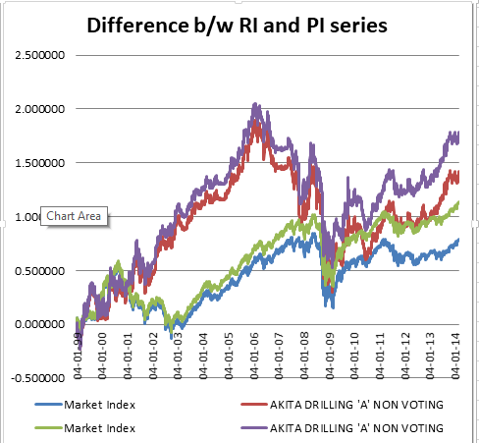

Difference between RI and PI data

**(VI)-Covariance Matrix**

In probability theory and statistics, a **covariance matrix** (also known as dispersion **matrix** or **variance**–**covariance matrix**) is a **matrix** whose element in the i, j position is the **covariance** between the i-th and j-th elements of a random vector. ... Each element of the vector is a scalar random variable.

A **variance**-**covariance matrix** is a square **matrix** that contains the **variances** and **covariances** associated with several variables. The diagonal elements of the **matrix** contain the **variances** of the variables and the off-diagonal elements contain the **covariances** between all possible pairs of variables.

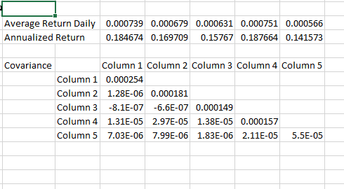

Covariance Matrix and Average Return Daily and Annually

**Calculation=**

Average Return =Sum of return of each day/ total no of days.

Annually Return =average return*250(no of days)/

**(VII)-Markowitz method-**

This relationship is expressed by beta (*β*), a standardized covariance to the market portfolio variance. Therefore, there is a linear relationship between the return on assets.

**First active Solver in excel-**

**Load the Solver Add-in in Excel**

1. In **Excel** 2010 and later, go to File > Options.
2. Click Add-Ins, and then in the Manage box, select **Excel** Add-ins.
3. Click Go.
4. In the Add-Ins available box, select the **Solver** Add-in check box, and then click OK. ...
5. After you load the **Solver** Add-in, the **Solver** command is available in the Analysis group on the Data tab.
6. 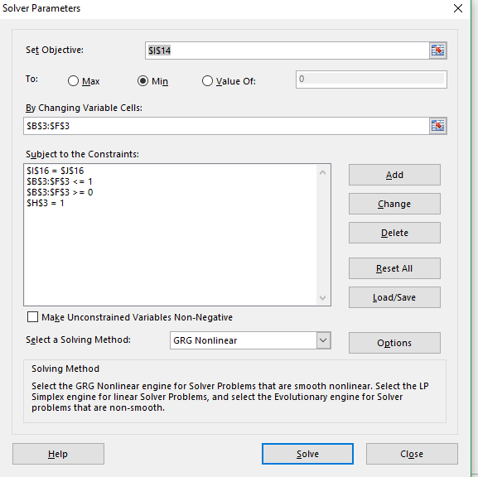
7. Solver will work like this after installation completed.

**Weights of each Stock –**

It show the amount of stock will be invested in each stock.

1-It depend on target value.

2-Covariance Matrix of each Stock.

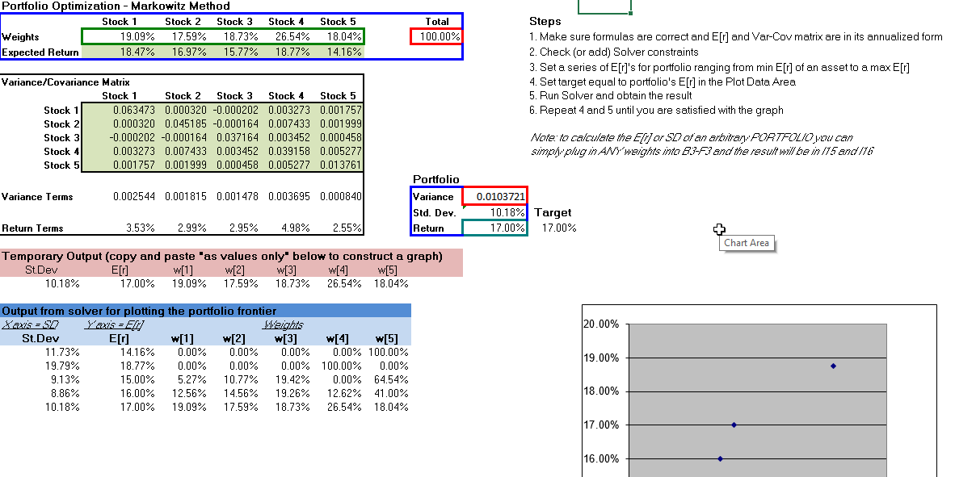

Markowitz Method

**It shows-**

(i)-Expected Return of each Stock-Amount that is return by each stock.

(ii)-Graph shows the Target return of each Stock.

(iii)-Run this model for many target value so the many expected value can be calculated easily.

This the Monte Carlo Simulation.